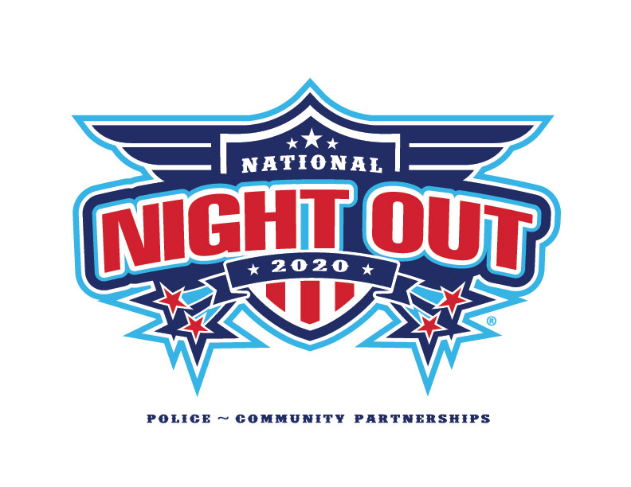
National Night Out is a crime prevention program intended to have a positive impact on reducing crime and drugs in our neighborhoods through participation by residents.

Join your neighbors for the 2020 National Night Out!
Block Party
MEET AND VISIT WITH YOUR NEIGHBORS
Tuesday, October 6, 2020

Block Party Address:
(Insert Address and Time Here)

R.S.V.P. Contact:
(Your Name, Phone and/or Email Here)

PLEASE BRING THE FOLLOWING:
Donation for SACA food shelf – non-perishable food item or check

